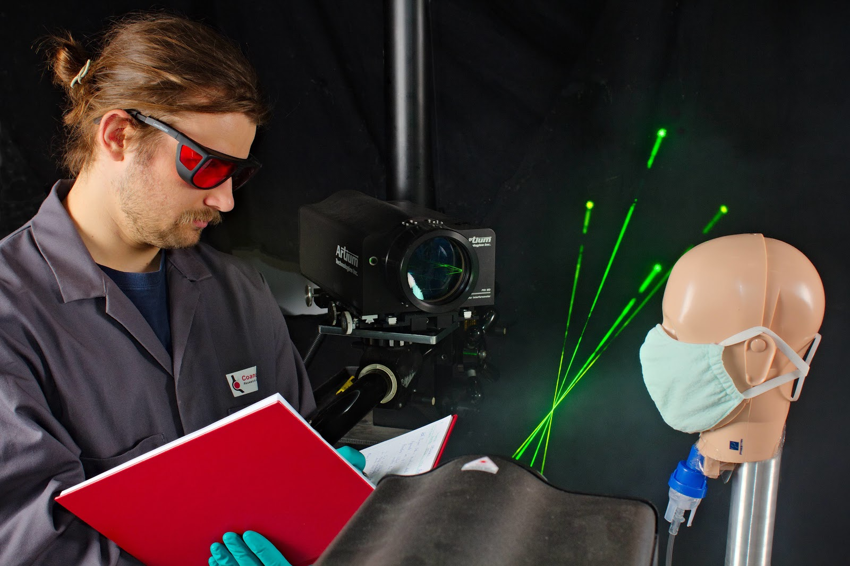
A Burnaby company, Coanda Research & Development Corp., established industrial engineering research consultants, has developed a device to test COVID-19 face masks for Albertan clothing manufacturer Canadian Zodiac.

COVID-19: Canadian Companies Team Up to Produce Better Face Masks

Coanda Research sets up testing facility to help Albertan manufacturer build better PPE.
A western Canadian engineering company, Coanda Research & Development Corporation, is partnering with Calgary garment manufacturer, Canadian Zodiac to develop and manufacture face masks. Coanda has set up a testing facility in its Burnaby laboratory to help Zodiac evaluate the suitability of using readily accessible materials for face mask manufacturing. Coanda’s team of scientists and engineers launched the program late last month, testing a wide range of materials.

The need for face masks has spurred clothing manufacturers such as Canadian Zodiac to switch their production facility from making garments to producing masks. “Pivoting our production to make masks has allowed us to keep our staff employed” said Zodiac’s co-founder Rich Allan in an interview.

Zodiac was able to reconfigure its manufacturing quickly – using the fabrics they already had on hand meant a fast production turnaround could be achieved but raised an important concern: “Do improvised masks actually work?” To answer this simple question, Allan reached out to Coanda’s Calgary office to see if they could help.

Coanda Research typically focuses its engineers, physicists, and mathematicians on large-scale industrial problems; but CEO Dr. Darwin Kiel knew his team had the right skillset to produce current, state-of-the-art information to help track how Covid-19 spreads. “Mask testing is just one of several Covid-19 related projects we are currently involved with,” Kiel added.

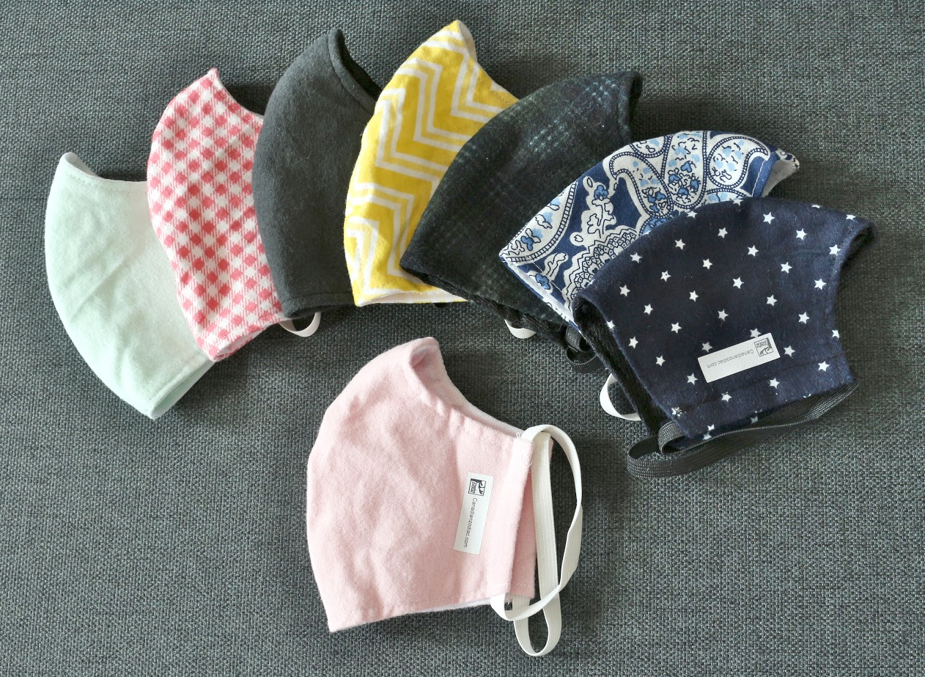
Canadian Zodiac’s multi-layered face masks are made using regular clothing materials such as brushed cotton flannel.

The Coanda team is studying the performance of different mask materials and methods of construction by spraying atomized liquid through various designs in a controlled lab environment, evaluating the filtering effectiveness using advanced laser measurement techniques.

Progress is already well underway. Testing results indicate that masks constructed from tightly woven textiles made of natural fibres and having a napped texture, such as brushed cotton flannel, provide the best filtration of droplets in the 1-10 micron range, and that multiple layers are more effective than single ones. These findings are consistent with the current recommendations by public health authorities, which are based primarily on measurements of sub-micron particles.

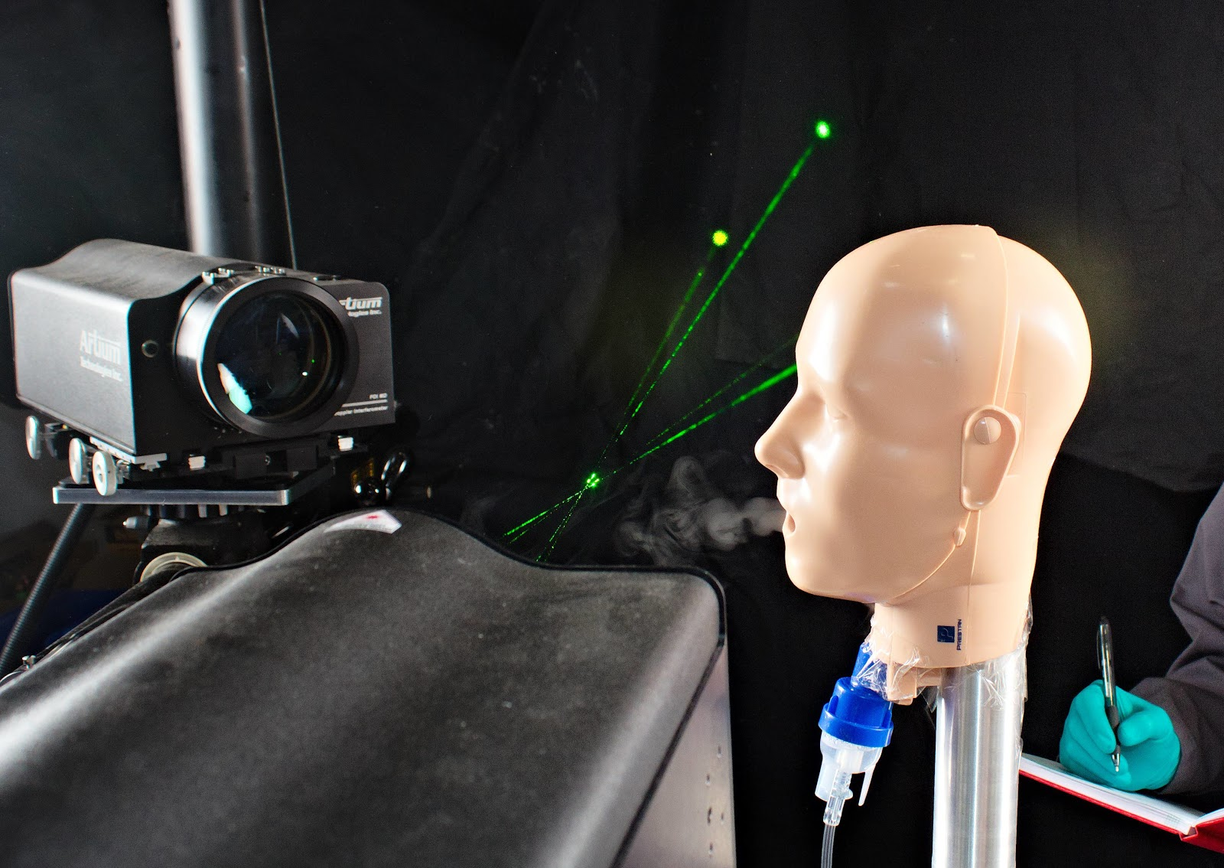
Coanda is using advanced laser measurement techniques to evaluate filtering performance.

Meanwhile, Canadian Zodiac’s first shipments of masks have already been donated to authorities as far afield as Atlantic Heath who operate facilities in hard hit areas such as New York and New Jersey. Masks are also available online at canadianzodiac.com for purchase by the general public for $15, although priority is given to frontline workers and service providers.

Further information on Coanda’s COVID-19 response and related initiatives is available on their website at coanda.ca

